14.13: a)
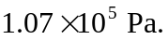 b) Repeating the calcultion with 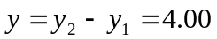cm instead of 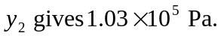 c) The absolute pressure is that found in part (b), 1.03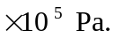
d) 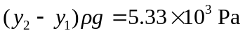(this is not the same as the difference between the results of parts (a) and (b) due to roundoff error).

